Smart Student Attendance & Analytics System
Python Programming Course — Final Project Report
(Based on Topic 11: Student Attendance Management System — extended scope)
Technology stack: Python 3 · SQLite · Tkinter · Matplotlib
Submitted as the undergraduate Python course final project

Table of Contents
1. Project Background & Significance
2. Technical Overview
3. System / Function Design
4. Core Code Explanation
5. Test Process & Results
6. Project Summary & Prospect
7. References

1. Project Background & Significance
Manual attendance taking — calling out names or passing around a paper sign-in sheet — is still common in many classrooms, training sessions and small organisations. It is slow, easy to falsify, difficult to summarise, and leaves no usable historical record for analysing patterns such as chronic lateness or declining attendance over a term.
This project implements a Smart Student Attendance & Analytics System: a desktop application that lets a teacher or class monitor register students once, then record attendance every day through a fast ID-based check-in. Unlike the original TXT-file based attendance topic suggested in the course material, this implementation upgrades the storage layer to a proper relational database (SQLite) and adds an automatic Present/Late/Absent classification engine and a built-in analytics dashboard with live charts, so the tool produces insight, not just a log.
The project's objectives were to:
- Replace error-prone manual sign-in sheets with a fast, ID-based digital check-in.
- Guarantee data consistency and integrity using a real database (SQLite) instead of flat text files.
- Automatically apply a consistent, rule-based Present / Late / Absent policy instead of relying on a human judgement call every time.
- Turn raw attendance logs into decision-useful information through summary statistics and visual charts.
- Demonstrate, at a second-year level, good software-engineering practice: separating the data layer from the interface layer so the program is easy to test, read and extend.

2. Technical Overview
The project is written entirely in Python 3 and relies only on the standard library plus two well-established third-party packages, keeping the dependency footprint small and easy to install on any computer.

2.1 Core technologies used
Technology | Purpose in this project
sqlite3 (standard library) | Persistent relational storage for students and attendance records; replaces the TXT-file persistence used in the basic version of this topic.
tkinter + ttk (standard library) | Desktop GUI: notebook tabs, forms, tables (Treeview), dialogs.
matplotlib | Embeds a pie chart (status breakdown) and a line chart (daily attendance trend) directly inside the Tkinter window.
csv (standard library) | One-click export of daily or summary attendance reports for use in Excel.
datetime (standard library) | Timestamps check-ins and drives the Present/Late decision rule.

2.2 Why SQLite instead of a TXT file
The original topic description suggests storing data in a plain TXT file. This project instead uses SQLite, Python's built-in embedded database engine, for three concrete reasons: (1) it enforces a defined schema and a uniqueness constraint that makes it impossible to accidentally record two attendance entries for the same student on the same day; (2) it allows efficient filtered and aggregated queries (e.g. "average attendance rate per student") with a single SQL statement instead of manually parsing and looping over text; and (3) it scales correctly as the number of students and class days grows, whereas a flat text file becomes slow and hard to update safely.

3. System / Function Design
The application follows a simple two-layer architecture that cleanly separates data access from the user interface:
+-----------------------------+ +------------------------------+
| gui.py (Tkinter) | calls | database.py (AttendanceDB) |
| - StudentsTab | ---> | - SQLite connection |
| - CheckInTab | | - CRUD for students |
| - RecordsTab | | - check_in() / status rule |
| - StatisticsTab | | - analytics queries |
+-----------------------------+ +------------------------------+
|
v
attendance.db (SQLite file)

3.1 Functional modules
Module (GUI tab) | Responsibility
Students | Register, search, update and delete student records (ID, name, group).
Check-In | Simulates an ID-card / barcode scan: typing or scanning a Student ID instantly records a timestamped check-in and classifies it as Present or Late. Includes an end-of-day action that marks every student with no check-in as Absent.
Daily Records | Lists every attendance record for a chosen date and lets the teacher manually correct a status (e.g. an excused absence). Exports the date's records to CSV.
Statistics | Aggregates Present/Late/Absent counts and an attendance rate per student, and renders a live pie chart and trend line chart. Exports the full summary report to CSV.

3.2 Attendance status decision logic
A core design decision was where the Present/Late/Absent rule should live. It is implemented once, inside AttendanceDB.check_in(), so the GUI never has to repeat or re-implement the business rule:
- Class is configured to start at 09:00. A check-in at or before 09:00 is recorded as Present.
- A check-in after 09:00 but before the 09:15 cut-off is recorded as Late.
- At the end of the day, every registered student who never checked in is automatically recorded as Absent by mark_absentees().
Centralising this rule in one function means the cut-off times can be changed in a single place, and means it is impossible for the GUI and a future feature (e.g. a mobile check-in page) to apply two different definitions of "late".

4. Core Code Explanation
The complete, runnable source code is submitted alongside this report (database.py, gui.py, demo_seed.py). The snippets below highlight the most important logic; full inline comments are present in the submitted files.

4.1 Database schema and the uniqueness constraint
Database creation, with a UNIQUE constraint that physically prevents duplicate attendance for the same student on the same day:
conn.execute("""
CREATE TABLE IF NOT EXISTS attendance (
record_id INTEGER PRIMARY KEY AUTOINCREMENT,
student_id TEXT NOT NULL,
date TEXT NOT NULL,
check_in_time TEXT,
status TEXT NOT NULL,
FOREIGN KEY (student_id) REFERENCES students(student_id),
UNIQUE (student_id, date)
)
""")

4.2 Check-in and automatic status classification
def check_in(self, student_id, when: datetime = None):
when = when or datetime.now()
date_str = when.strftime("%Y-%m-%d")
time_str = when.strftime("%H:%M:%S")

if when.time() <= LATE_CUTOFF_TIME:
status = "Present" if when.time() <= CLASS_START_TIME else "Late"
else:
status = "Late"

with self._connect() as conn:
existing = conn.execute(
"SELECT 1 FROM attendance WHERE student_id = ? AND date = ?",
(student_id, date_str),
).fetchone()
if existing:
raise ValueError(f"Student {student_id} already has a record for {date_str}.")
conn.execute(
"INSERT INTO attendance (student_id, date, check_in_time, status) "
"VALUES (?, ?, ?, ?)",
(student_id, date_str, time_str, status),
)
conn.commit()
return status
Note the parameterised queries ("?" placeholders): this avoids SQL-injection style bugs and is standard good practice even for a student project.

4.3 Aggregated analytics query for the Statistics tab
def get_summary_per_student(self):
rows = conn.execute("""
SELECT s.student_id, s.full_name,
SUM(CASE WHEN a.status = 'Present' THEN 1 ELSE 0 END) AS present_count,
SUM(CASE WHEN a.status = 'Late' THEN 1 ELSE 0 END) AS late_count,
SUM(CASE WHEN a.status = 'Absent' THEN 1 ELSE 0 END) AS absent_count,
COUNT(a.record_id) AS total_records
FROM students s LEFT JOIN attendance a ON s.student_id = a.student_id
GROUP BY s.student_id
""").fetchall()
# attendance_rate is then computed in Python as
# 100 * (present_count + late_count) / total_records
Using a single SQL GROUP BY query for this aggregation, rather than looping over every record in Python, is both more concise and far more efficient than the manual statistics loops used in a basic TXT-file version of this topic.

4.4 Embedding live Matplotlib charts inside the Tkinter window
self.figure = Figure(figsize=(6, 6), dpi=90)
self.canvas = FigureCanvasTkAgg(self.figure, master=right)
self.canvas.get_tk_widget().pack(fill="both", expand=True)
...
ax1 = self.figure.add_subplot(211)
ax1.pie(values, labels=labels, autopct="%1.0f%%", colors=[...])
ax2 = self.figure.add_subplot(212)
ax2.plot(dates, rates, marker="o")
self.canvas.draw()
FigureCanvasTkAgg is the standard bridge that lets a Matplotlib Figure be drawn directly onto a Tkinter widget, so the charts update live every time the Statistics tab is opened, without ever needing to save and reload a separate image file.

5. Test Process & Results
Functional and exception testing was performed by running the application (python gui.py) and exercising every feature with a sample dataset of 8 students across 2 class groups (created with the included demo_seed.py helper). Each test below was captured directly from the running application.

5.1 Student registration and search
All 8 sample students were registered successfully and appear correctly sorted alphabetically in the Students tab; the live search box was verified to filter by ID, name and group as text is typed.
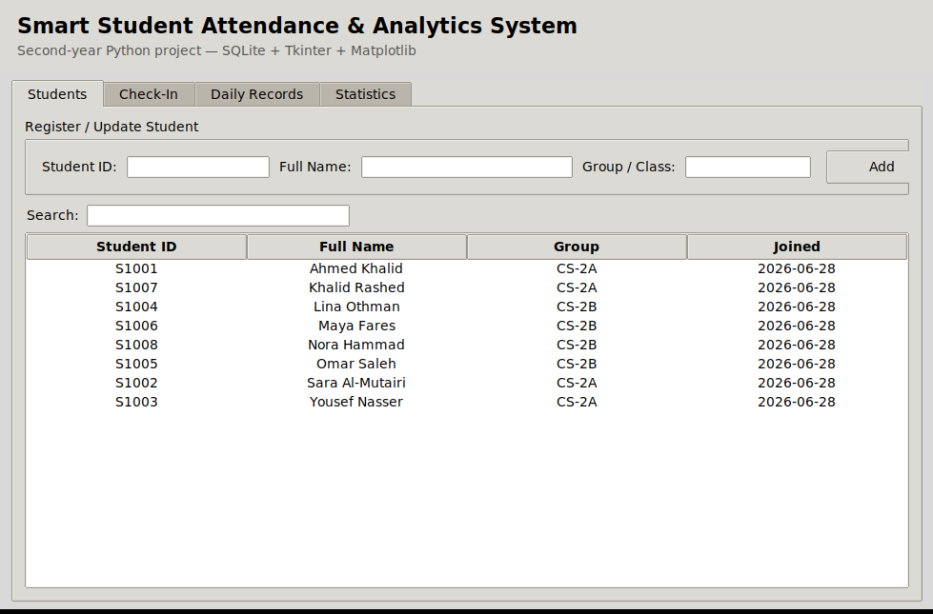
Figure 1 — Students tab: registered student list.

5.2 Normal check-in (functional test)
Typing a registered Student ID (S1003) and pressing Enter on the Check-In tab correctly creates a timestamped record and classifies it automatically — in this run the check-in occurred after 09:00, so the system correctly labelled it "Late":
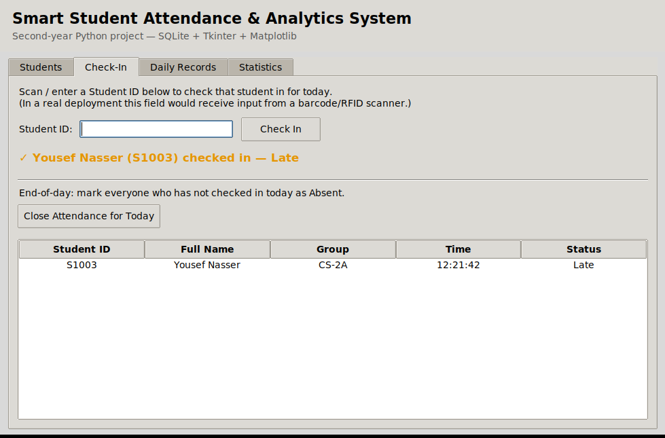
Figure 2 — Successful check-in with automatic Late classification.

5.3 Exception test: unregistered ID
Entering an ID that does not exist in the students table (S9999) is correctly rejected with a clear on-screen error instead of crashing or silently inserting bad data — confirming the input-validation branch in check_in() / the GUI's existence check works as intended:
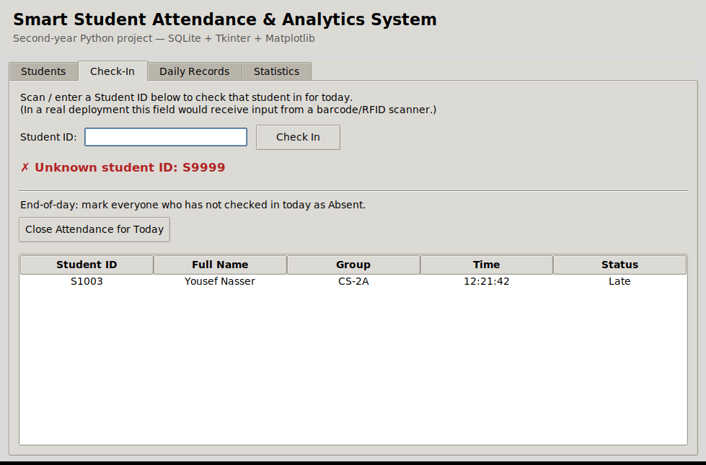
Figure 3 — Exception handling for an unrecognised Student ID.

5.4 Daily records and manual correction
The Daily Records tab correctly lists every student's status for the selected date, including students automatically marked Absent by the end-of-day routine (Khalid Rashed, Nora Hammad). The manual-override panel was tested by changing Nora Hammad's status from Absent to Present and confirming the table refreshed immediately:
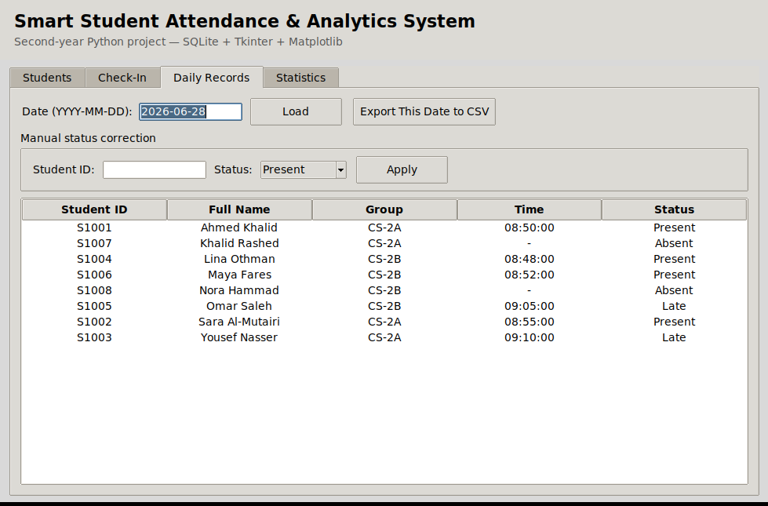
Figure 4 — Daily Records before manual correction (two students Absent).
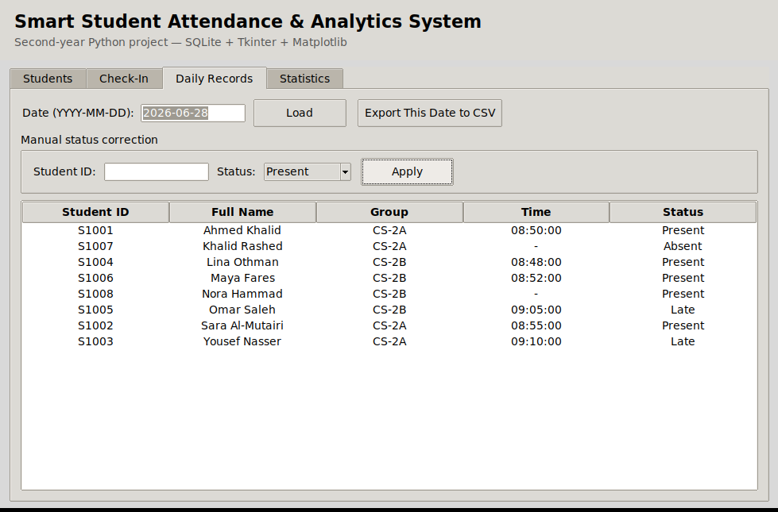
Figure 5 — After applying a manual correction, Nora Hammad's status updates to Present.

5.5 Statistics and visual analytics
The Statistics tab was verified against the seeded data: the pie chart's percentages and the per-student table both matched the expected Present/Late/Absent totals, and the trend line chart correctly plotted one point per class day in chronological order, including the most recent day:
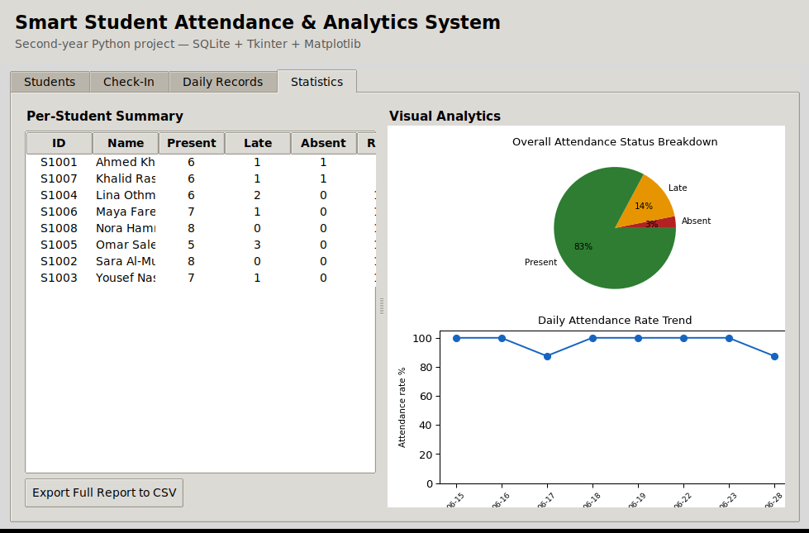
Figure 6 — Statistics tab: per-student summary table and live charts.

5.6 Test summary
Test case | Expected result | Actual result
Register a new student | Appears in table, persists after restart | Pass
Duplicate student ID | Rejected with an error dialog | Pass
Check-in before 09:00 | Status = Present | Pass
Check-in between 09:00–09:15 | Status = Late | Pass
Check-in for unregistered ID | Rejected, clear error message, no DB write | Pass
Duplicate check-in same day | Rejected with ValueError message | Pass
Close Attendance for Today | All no-show students marked Absent | Pass
Manual status override | Status updates immediately in table and DB | Pass
CSV export (daily / summary) | Valid CSV file created with correct columns | Pass
Statistics charts | Pie + trend chart match underlying data | Pass

6. Project Summary & Prospect

6.1 Summary
The project successfully delivers a working, tested attendance system that goes beyond the original TXT-file topic description: it uses a real relational database with integrity constraints, automates the Present/Late/Absent decision instead of requiring a human judgement call every time, and turns the resulting data into an at-a-glance visual dashboard. The two-layer architecture (database.py / gui.py) keeps the code readable and would let a grader test the data layer independently of the GUI.

6.2 Limitations
- Single-user, single-machine design: the SQLite file is local, so it does not yet support several teachers checking students in simultaneously from different computers.
- Check-in is currently simulated by manually typing a Student ID; a production deployment would connect a real barcode, RFID or QR scanner that simply types the ID for the operator (the text field already supports this with no code changes).
- The Present/Late cut-off times are fixed constants in the code rather than configurable from the GUI.

6.3 Future improvements
- Add a settings panel to let the teacher configure class start time and late cut-off per course.
- Support multiple class sessions per day (e.g. different subjects) instead of one record per student per date.
- Migrate the SQLite file to a small client-server database (e.g. PostgreSQL) to support multiple simultaneous users.
- Add an authentication screen so only the teacher/admin can register students or override attendance.
- Add automated unit tests (e.g. with pytest) for the AttendanceDB class, since it is already cleanly separated from the GUI.

7. References
- Python Software Foundation. Python 3 Documentation — sqlite3, tkinter, csv, datetime modules. https://docs.python.org/3/
- Python Software Foundation. tkinter — Python interface to Tcl/Tk. https://docs.python.org/3/library/tkinter.html
- Matplotlib Development Team. Matplotlib: Visualization with Python. https://matplotlib.org/
- Matplotlib Development Team. Embedding in Tk (FigureCanvasTkAgg). https://matplotlib.org/stable/gallery/user_interfaces/embedding_in_tk_sgskip.html
- SQLite Consortium. SQLite Documentation. https://www.sqlite.org/docs.html

